Read Me
20 October 2011
“Wired Broadband and Related Industry Glossary of Terms with Acronyms”
Hopefully helpful hints for using the referenced Glossary are listed below.
Glossary organization:
The Glossary is written in Microsoft Word™ and is organized by subject using either a leading number from zero (0) to nine (9) or a leading letter of the alphabet, A through Z, in alphabetical order. In the number section, the leading position determines place within the document followed by second position character and so on. For example, 1024-QAM is listed ahead of 16-QAM (since the first (leading) position numbers match and the second position number is lowest for “1024-QAM”).
Following subject matter are the Bibliography and a list of Trademarks. In most cases, individual subject matter is referenced by one or more source citation within subject matter text. If no citation is listed, the source is either the CableLabs Glossary of Terms or CableLabs Acronym List listed in the Bibliography or is derived by the author.
Searching for Subject Matter:
Several methods may be used to locate subject matter, starting with use of a Microsoft Word™ feature called the “Bookmark”. Open the Glossary (Word™ document). LEFT click the “Insert” pull down menu at the upper left of the document header. The “Bookmark” pull down menu will now be visible near the center of the pull down options (see screen shot below).
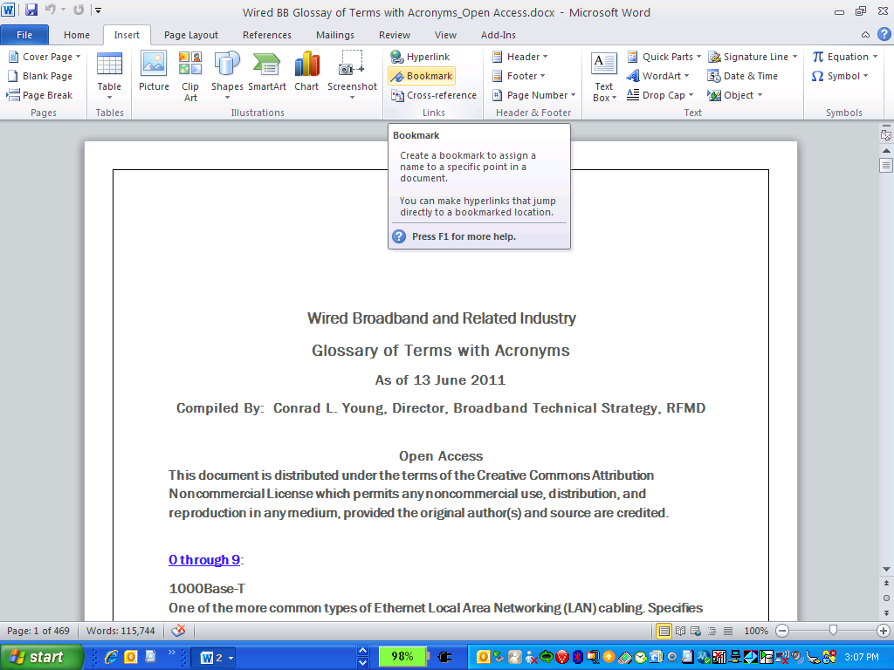
LEFT click the “Bookmark” pull down menu. You will now see the following window superimposed over the Glossary:
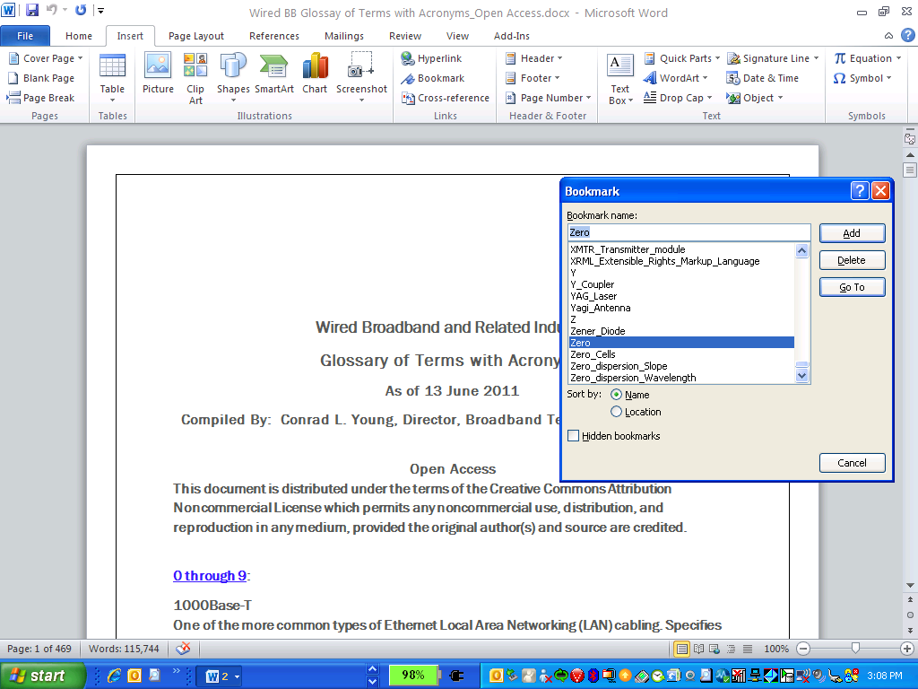
Under “Bookmark name:” clear the tab by clicking on the highlighted text in this field (if there is any shown). Now you can type the subject desired in this field (see screenshot below):
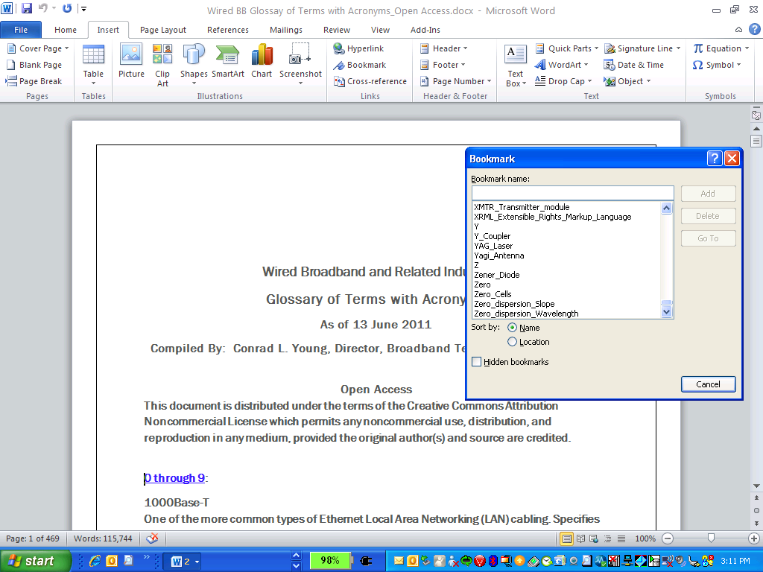
You may type in any individual letter of the alphabet, A through Z, in order to go to any Glossary heading by letter, as each letter of the alphabet is individually bookmarked in the Glossary. To go to the “NUMBER” section, you must type in the word “Zero”, as Microsoft Word™ “Bookmark” rules do not permit leading any “Bookmark” description with a number or non alphabet character. Other “Bookmark” rules include the inability to employ the hyphen and a limit of forty (40) characters per individual “Bookmark” description. Where a hyphen is called for the author has employed the “underscore” (_) character in its place. The author also employed the underscore (_) symbol to “space” Subject description words for clarification of meaning and ease of search. Below the example of locating and going to “Zero” is shown below. Type in the word “Zero” under “Bookmark name:” LEFT click the “Go To” button. You will be taken to the “0 through 9” section of the Glossary.
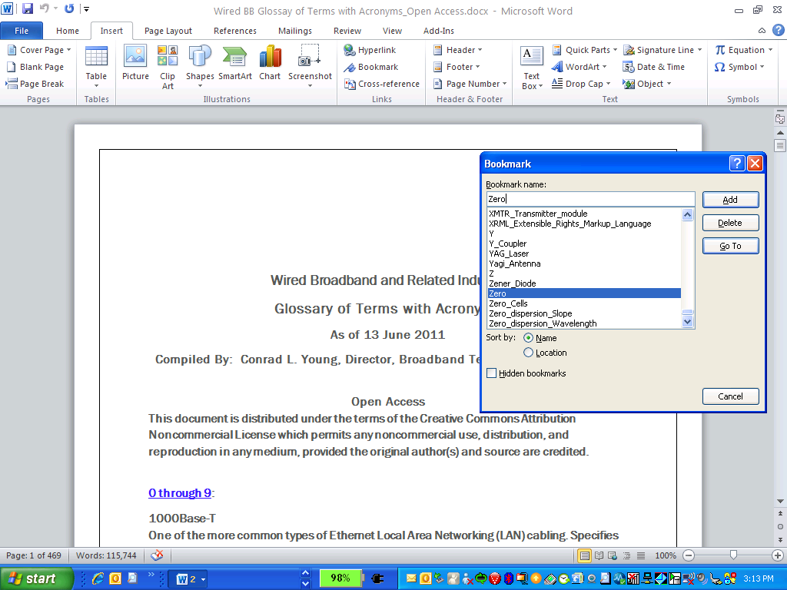
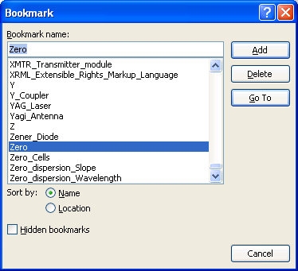
After clicking the “Go To” button, you will notice the following screen (note the “Add” button is no longer a selectable option as you have employed the “Bookmark” feature to “Go To” a document “Bookmark”).
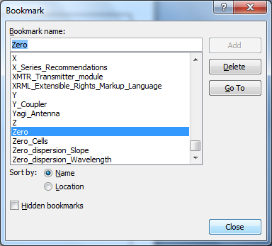
Click the “Close” button to close the “Bookmark” options window.
Note that there are no “Hidden bookmarks” in the Glossary. Note that most Subjects found in the Glossary (> 460 pages worth) are listed in the “Bookmark” directory list. To find a Subject not listed in the “Bookmark” directory, find a Subject close in alphabetical order and “Go To” that Subject to get close to the desired location.
Another viable option for finding desired Subject matter is to use the Microsoft Word™ “Find” feature. With the Glossary open, LEFT click the “Home” pull down menu at the far left of menu options. Now LEFT click the “Find” pull down option at the far right of menu options as shown in the screen shot below.
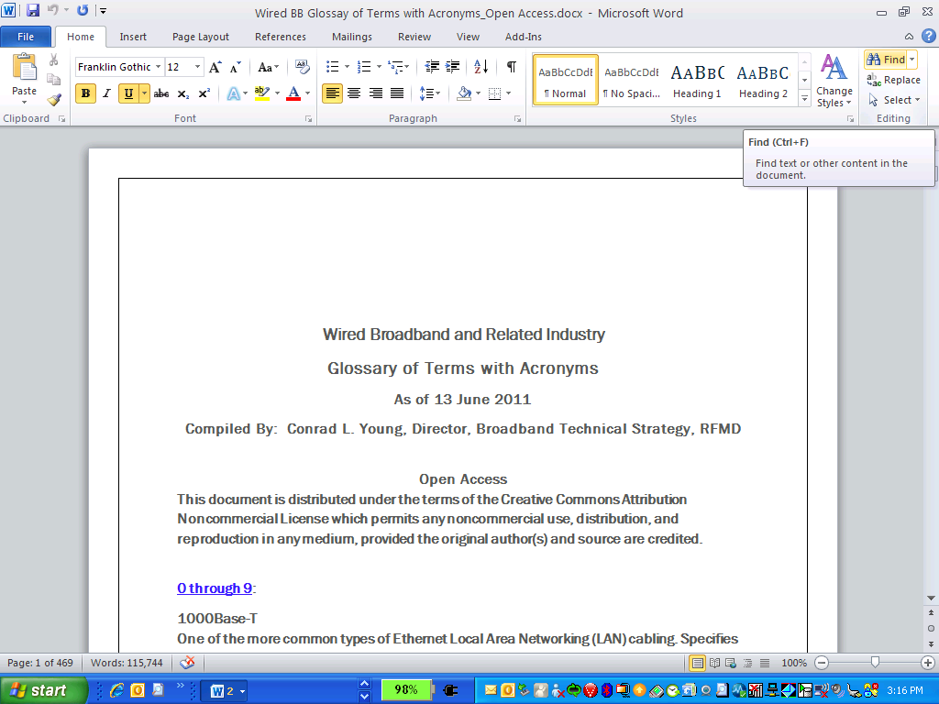
You can also use the “Ctrl + F” keys to access the “Find and Replace” options window as shown in the screen shot below.
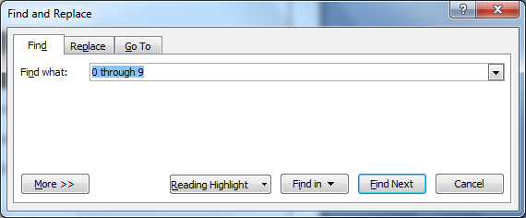
Select the “Find” tab within the now open “Find and Replace” window. In the “Find what:” bar, type in exactly what you want to find. Click the “Find Next” button. An example for finding “M-ary QAM” is shown in the following text with screen shots.

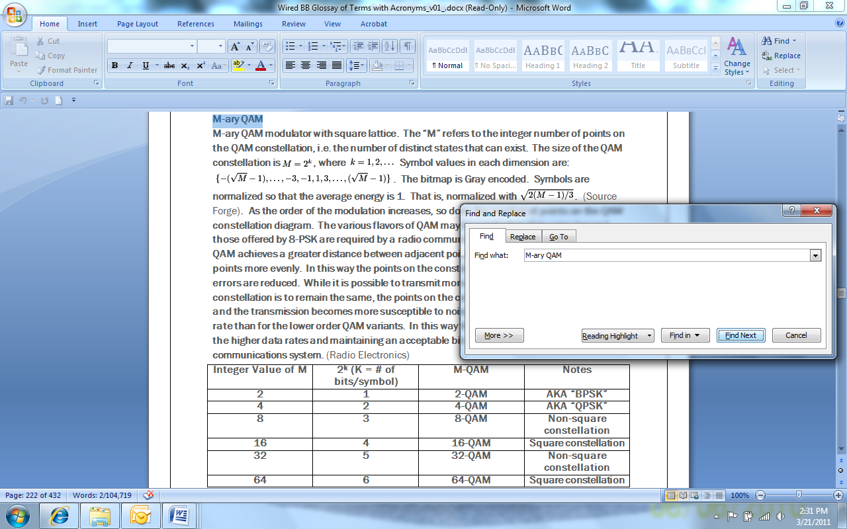
The Glossary is written using Microsoft Word™ so it may be saved as a Word™ document for reference and modified over time by the user as desired.
Considerable effort was expended to credit all known sources for the information contained within this Glossary. The author assumes no liability for the public display of the information contained herein.
SINCERELY,
Conrad Young

